DNS Anomaly Detection

Purpose OF The Project:
Performing anomaly detection on a synthetic DNS traffic dataset using multiple models such as isolation forest, K_means and One class SVM.
Data used is unsupervised (no labels), however when using the models to detect anomalies, it creates cvs file contain its own detected anomalies.

Overview Of Dataset:

- Data set has 1000 rows and 6 columns.
- Features are Timestamp, Source_IP, Destination_IP, Query_Volume, TTL_Value and Transaction_ID_Entropy
- The features that affect detecting anomalies are Query_Volume, TTL_Value and Transaction_ID_Entropy so these will be selected to train the model.

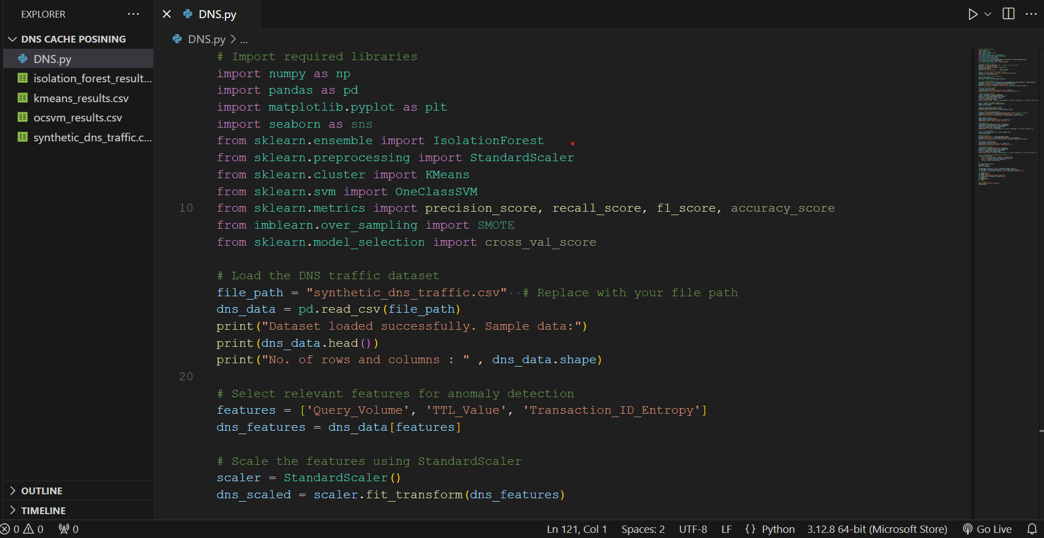
Part 1:
Import required libraries and read data with csv extension using pandas.
Show the first 5 rows of data using head () function.
To know the number of rows and columns in the data, shape () function will be used.
Select features which affect most in detecting anomalies.
Perform normalization of data to ensure that all values have equal importance and to avoid model bias.

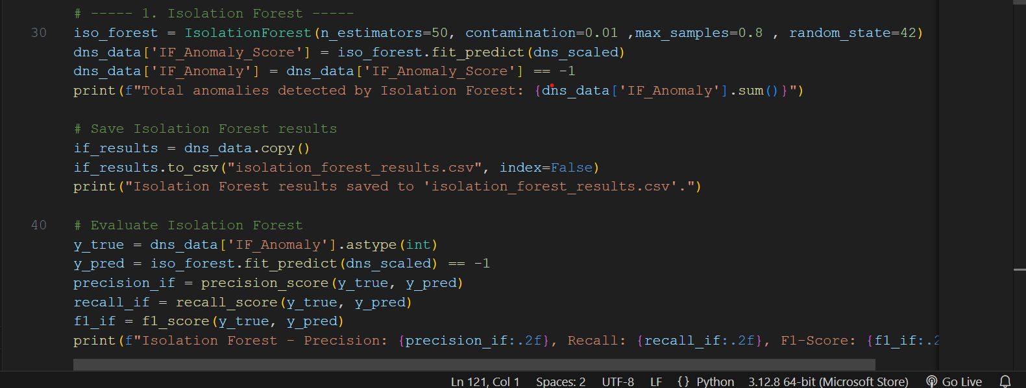
Part 2:
Apply models to analyze data and detect anomalies:
First, we apply isolation forest ensemble algorithm which is an algorithm primarily used for anomaly detection. Use isolation concept that isolates anomalies by recursively partitioning the data using random splits, ensemble of trees concept that builds an ensemble of decision trees. Each tree is created by randomly selecting a subset of the data and performing random splits, Contamination concept which is parameter used to define the expected proportion of anomalies in the dataset.
Taking parameters such as n_estimator is the number of trees in the forest. More trees typically improve model performance, but it also increases computational cost. Contamination indicates that 5% of data is supposed to be anomaly, max_samples=0.8 means that only 80% of data will be randomly selected in data training.
The results of this model which are detected anomalies will be saved in csv file.
Model Evaluation: apply evaluated metrics such as precision, recall and F1-score.
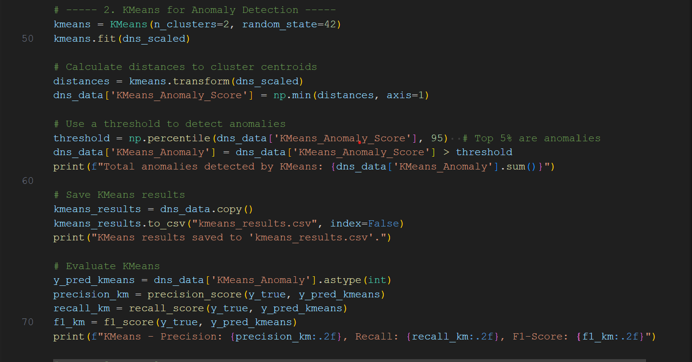
Part 3:
The second model applied is K-means.
This clustering technique works on unsupervised data by understanding relationships among data and collecting the similar points in one cluster.
Determine these relationships based on calculation of distance between data. Assume number of clusters here are 2 clusters and separate between them using threshold.
Detected Anomalies using k-means will be saved also in csv file.
Apply evaluation metrics to evaluate model (precision, recall and F1-score).

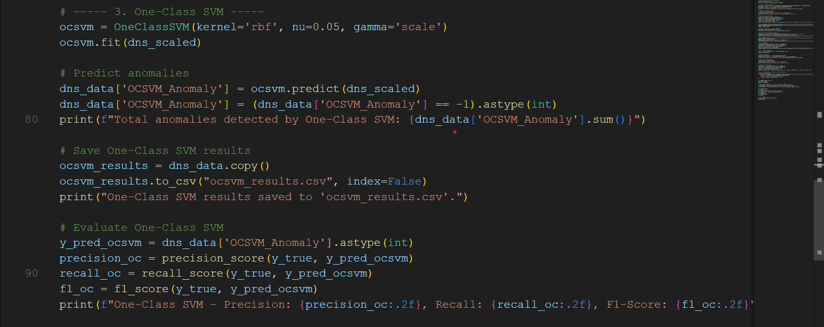
Part 4:
The last model will be used is One-Class SVM:
This is unsupervised technique for anomaly detection that separates normal data points from anomalies by learning a boundary in the feature space.
Take parameters such as: kernel='rbf' that define Radial Basis Function (RBF) kernel that is popular kernel function used in SVM to handle non-linear relationships in data. nu=0.05 determines the upper bound of anomalies in data. Here equals 0.05 which means the model assumes that approximately 5% of the data are anomalies.
Save the anomalies result in csv file and apply evaluation metrics to evaluate model.

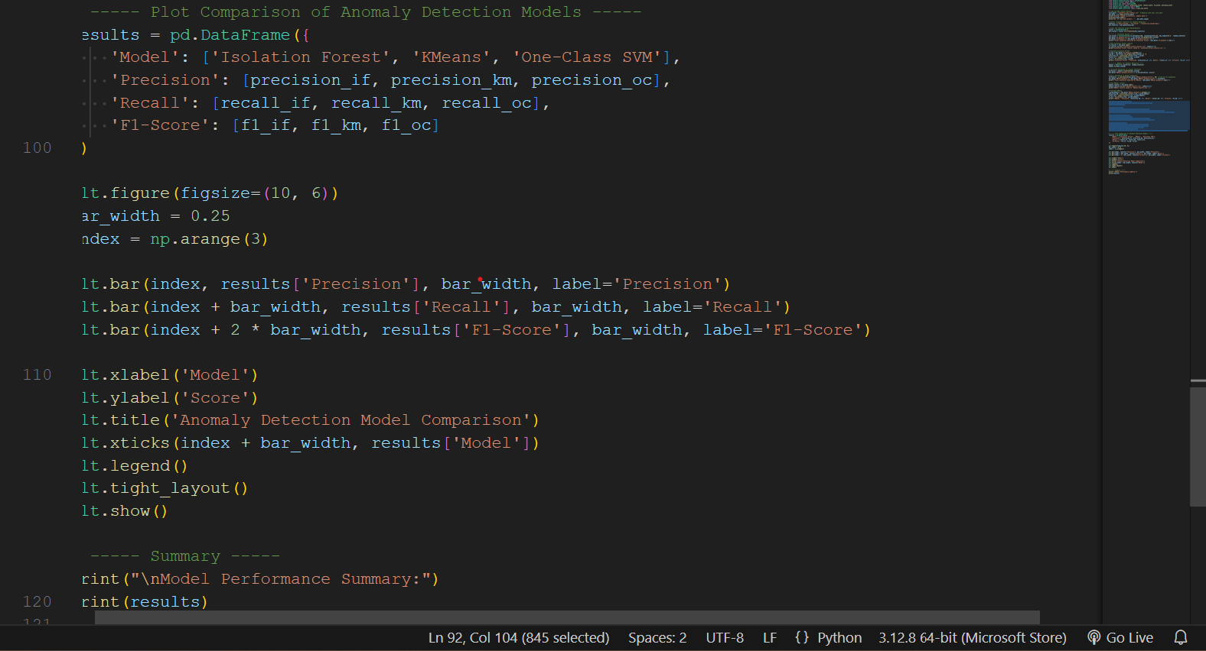
Part 5 :
Finally, there is a plot that visualizes a comparison between three models based on evaluation metrics.

